Adrien Protzel

1. 1. One-Hot: gives a binary representation to the points and makes each of them the same distance from each other.
   2. Ordinal: gives values 1,2,3… and marks each point at different distances.
2. There are 1136 >50k data points which is around 14.2%. Its success rate for <50k would be around 86%, so 70% would be too low. There are 85 dimensions.
3. △v = x - z => ||△v|| = ||x - z||=>the distance between two vectors in a straight line=> L2 norm of the ||x-z||2
4. -
5. -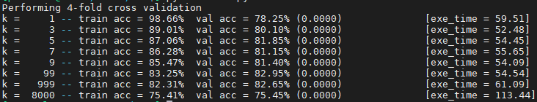

99 was the best. Training is not 0%. Given training data can make outliers in the data read. While k increased, training accuracy decreased continuously, val acc increased until 99 then decreased in a similar rate. The early K high training acc means high overfitting while it has underfitting as k increases too much.

Debriefing:

1. About 24 hours spread over the weeks.
2. Moderate-hard
3. Alone with some help from friends mainly for math
4. I see what's happened in each functions scope but then stepping back to see how each flows into each other took some time
5. Please be gentle in grading